**LAB CYCLE 1**

**1. Program to Print all non-Prime Numbers in an Interval.**

**Code:**

print("Name: Annjish Kunjumon")

print("Reg no: SJC22MCA-2009")

print("Batch:2022-2024")

lower_value=int(input("Enter the Lowest Range value:"))

upper_value=int(input("Enter the upper Range value:"))

print("The non-prime numbers in range are:")

for number in range (lower_value,upper_value + 1):

if number > 1:

is_prime = True

for i in range(2, number):

if (number % i) == 0:

is_prime = False

break

if not is_prime:

print(number)

**Output:**

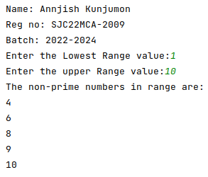

**2. Program to print the first N Fibonacci numbers.**

**Code:**

print("Name: Annjish Kunjumon")

print("Reg no: SJC22MCA-2009")

print("Batch: 2022-2024")

n= int(input("Limit of series:\n"))

a=0

b=1

count=0

if(n <= 0):

print("Invalid input..")

else:

print("Fibonacci Series.....")

while(count < n):

print(a)

next=a+b

a=b

b=next

count=count+1

**Output:**

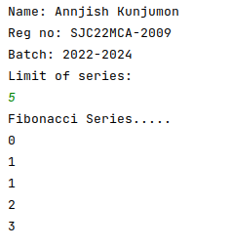

**3. Given sides of a triangle, write a program to check whether given triangle is an**

**isosceles, equilateral or scalene.**

**Code:**

print("Name: Annjish Kunjumon")

print("Reg no: SJC22MCA-2009")

print("Batch: 2022-2024")

print("Input length of Triangle Sides:")

x=int(input("x:"))

y=int(input("y:"))

z=int(input("z:"))

if( x == y == z):

print("Equilateral triangle")

elif(x == y or y==z or z==x):

print("Isosceles triangle")

else:

print("Triangle is Scalene")

**Output:**

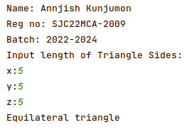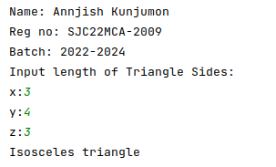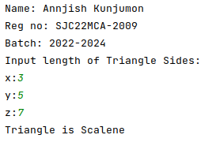

**4. Program to check whether given pair of number is coprime.**

Code:

import math

def are_coprime(a, b):

gcd = math.gcd(a, b)

return gcd == 1

print("Name: Annjish Kunjumon")

print("Reg no: SJC22MCA-2009")

print("Batch: 2022-2024")

print("-----------------------")

num1 = int(input("Enter the first number: "))

num2 = int(input("Enter the second number: "))

if are_coprime(num1, num2):

print(f"{num1} and {num2} are coprime.")

else:

print(f"{num1} and {num2} are not coprime.")

**Output:**

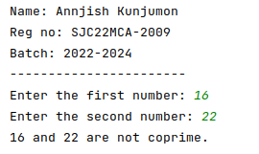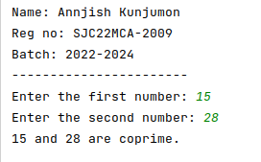

**5. Program to find the roots of a quadratic equation(rounded to 2 decimal places)**

**Code:**

print("Name: Annjish Kunjumon")

print("Reg no: SJC22MCA-2009")

print("Batch: 2022-2024")

print("-----------------------")

import math

a = float(input("Enter value of a: "))

b = float(input("Enter value of b: "))

c = float(input("Enter value of c: "))

discri = b**2 - 4*a*c

if discri > 0:

root1 = (-b + math.sqrt(discri)) / (2*a)

root2 = (-b - math.sqrt(discri)) / (2*a)

print(f"Root 1: {round(root1, 2)}")

print(f"Root 2: {round(root2, 2)}")

elif discri == 0:

root = -b / (2*a)

print(f"Root: {round(root, 2)}")

else:

real_part = -b / (2*a)

img_part = math.sqrt(-discri) / (2*a)

root1 = complex(real_part, img_part)

root2 = complex(real_part, -img_part)

print(f"Root 1: {root1.real:.2f} + {root1.imag:.2f}i")

print(f"Root 2: {root2.real:.2f} - {root2.imag:.2f}i")

**Output:**

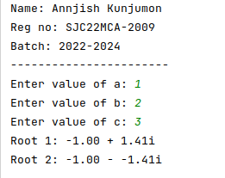

**6. Program to check whether a given number is perfect number or not(sum of factors=number)**

**Code:**

def is_perfect_number(num):

if num <= 0:

return False

sum_of_divisors = 0

for i in range(1, num):

if num % i == 0:

sum_of_divisors += i

return sum_of_divisors == num

try:

print("Name: Annjish Kunjumon")

print("Reg no: SJC22MCA-2009")

print("Batch: 2022-2024")

print("-----------------------")

num = int(input("Enter a number: "))

if is_perfect_number(num):

print(f"{num} is a perfect number.")

else:

print(f"{num} is not a perfect number.")

except ValueError:

print("Invalid input. Please enter a valid number.")

**Output:**

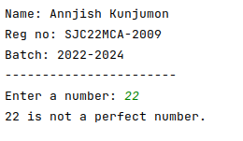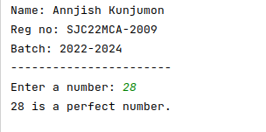

**7. Program to display armstrong numbers upto 1000.**

**Code:**

print("Name: Annjish Kunjumon")

print("Reg no: SJC22MCA-2009")

print("Batch: 2022-2024")

print("-----------------------")

print("Arm strong numbers upto 1000 are:")

for i in range(1,1000):

n=i

sum=0

while(i>0):

rem= i % 10

sum= sum + (rem * rem * rem)

i= i//10

if (sum == n):

print(n)

**Output:**

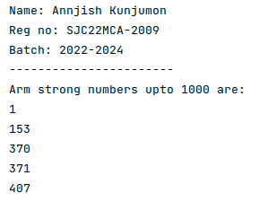

**8. Store and display the days of a week as a List, Tuple, Dictionary, Set. Also demonstrate different ways to store values in each of them. Display its type also.**

**Code:**

print("Name: Annjish Kunjumon")

print("Reg no: SJC22MCA-2009")

print("Batch: 2022-2024")

print("-----------------------")

days_list = ["Monday", "Tuesday", "Wednesday", "Thursday", "Friday", "Saturday", "Sunday"]

print("List:", days_list)

print("Type:", type(days_list))

days_tuple = ("Monday", "Tuesday", "Wednesday", "Thursday", "Friday", "Saturday", "Sunday")

print("Tuple:", days_tuple)

print("Type:", type(days_tuple))

days_dict = {0: "Monday", 1: "Tuesday", 2: "Wednesday", 3: "Thursday", 4: "Friday", 5: "Saturday", 6: "Sunday"}

print("Dictionary:", days_dict)

print("Type:", type(days_dict))

days_set = {"Monday", "Tuesday", "Wednesday", "Thursday", "Friday", "Saturday", "Sunday"}

print("Set:", days_set)

print("Type:", type(days_set))

**Output:**

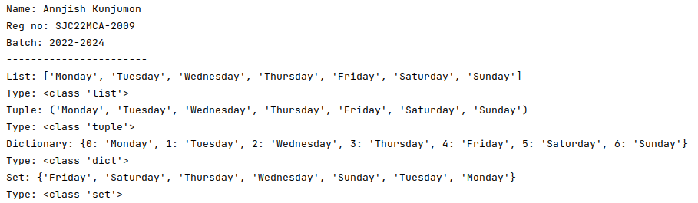

**9. Write a program to add elements of given 2 lists.**

**Code:**

def add_lists(list1, list2):

if len(list1) != len(list2):

return None

result = []

for i in range(len(list1)):

result.append(list1[i] + list2[i])

return result

try:

print("Name: Annjish Kunjumon")

print("Reg no: SJC22MCA-2009")

print("Batch: 2022-2024")

print("-----------------------")

list1 = input("Enter the first list of numbers separated by spaces: ").split()

list1 = [int(x) for x in list1]

list2 = input("Enter the second list of numbers separated by spaces: ").split()

list2 = [int(x) for x in list2]

result = add_lists(list1, list2)

if result is None:

print("The lists have different lengths and cannot be added.")

else:

print("Result of addition:", result)

except ValueError:

print("Invalid input. Please enter valid numbers separated by spaces.")

**Output:**

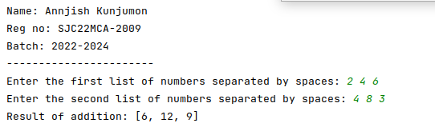

**10. Write a program to find the sum of 2 matrices using nested List.**

**Code:**

def add_matrices(matrix1, matrix2):

if len(matrix1) != len(matrix2) or len(matrix1[0]) != len(matrix2[0]):

return None

result = [[0 for _ in range(len(matrix1[0]))] for _ in range(len(matrix1))]

for i in range(len(matrix1)):

for j in range(len(matrix1[0])):

result[i][j] = matrix1[i][j] + matrix2[i][j]

return result

try:

print("Name: Annjish Kunjumon")

print("Reg no: SJC22MCA-2009")

print("Batch: 2022-2024")

print("-----------------------")

rows = int(input("Enter the number of rows: "))

cols = int(input("Enter the number of columns: "))

print("Enter elements of the first matrix:")

matrix1 = []

for i in range(rows):

row = input(f"Enter elements of row {i + 1} separated by spaces: ").split()

matrix1.append([int(x) for x in row])

print("Enter elements of the second matrix:")

matrix2 = []

for i in range(rows):

row = input(f"Enter elements of row {i + 1} separated by spaces: ").split()

matrix2.append([int(x) for x in row])

result = add_matrices(matrix1, matrix2)

if result is None:

print("Matrix dimensions are not compatible for addition.")

else:

print("Sum of matrices:")

for row in result:

print(" ".join(map(str, row)))

except ValueError:

print("Invalid input. Please enter valid numbers.")

**Output:**

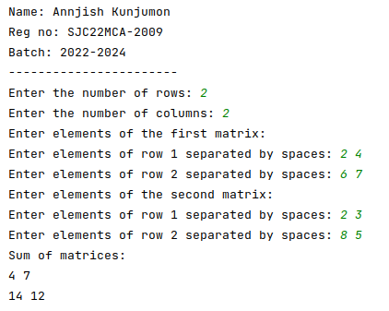

**11. Write a program to perform bubble sort on a given set of elements.**

**Code:**

def bubble_sort(arr):

n = len(arr)

for i in range(n):

swapped = False

for j in range(0, n - i - 1):

if arr[j] > arr[j + 1]:

arr[j], arr[j + 1] = arr[j + 1], arr[j]

swapped = True

if not swapped:

break

try:

print("Name: Annjish Kunjumon")

print("Reg no: SJC22MCA-2009")

print("Batch: 2022-2024")

print("-----------------------")

elements = input("Enter elements separated by spaces: ").split()

elements = [int(x) for x in elements]

bubble_sort(elements)

print("Sorted elements:")

print(elements)

except ValueError:

print("Invalid input. Please enter valid numbers separated by spaces.")

**Output:**

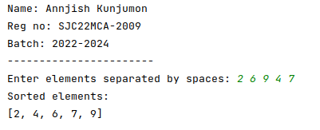

**12. Program to find the count of each vowel in a string(use dictionary).**

**Code:**

def count_vowels(string):

vowel_counts = {'A': 0, 'E': 0, 'I': 0, 'O': 0, 'U': 0}

string = string.upper()

for char in string:

if char in vowel_counts:

vowel_counts[char] += 1

return vowel_counts

try:

print("Name: Annjish Kunjumon")

print("Reg no: SJC22MCA-2009")

print("Batch: 2022-2024")

print("-----------------------")

input_string = input("Enter a string: ")

vowel_counts = count_vowels(input_string)

print("Vowel counts:")

for vowel, count in vowel_counts.items():

print(f"{vowel}: {count}")

except ValueError:

print("Invalid input. Please enter a valid string.")

**Output:**

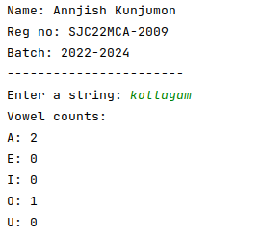

**13. Write a Python program that accept a positive number and subtract from this**

**number the sum of its digits and so on. Continues this operation until the number is positive**

**(eg: 256-&gt;2+5+6=13**

**256-13=243**

**243-9=232……..)**

**Code:**

def sum_of_digits(n):

digit_sum = 0

while n > 0:

digit_sum += n % 10

n //= 10

return digit_sum

try:

print("Name: Annjish Kunjumon")

print("Reg no: SJC22MCA-2009")

print("Batch: 2022-2024")

print("-----------------------")

num = int(input("Enter a positive number: "))

if num <= 0:

print("Please enter a positive number.")

else:

while num > 0:

digit_sum = sum_of_digits(num)

print(f"{num} - {digit_sum} = {num - digit_sum}")

num -= digit_sum

except ValueError:

print("Invalid input. Please enter a valid positive number.")

**Output:**

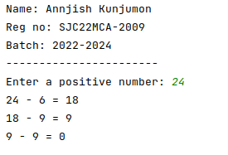

**14. Write a Python program that accepts a 10 digit mobile number, and find the digits which are absent in a given mobile number.**

**Code:**

def find_absent_digits(mobile_number):

all_digits = set("0123456789")

mobile_digits = set(mobile_number)

absent_digits = all_digits - mobile_digits

return sorted(list(absent_digits))

try:

print("Name: Annjish Kunjumon")

print("Reg no: SJC22MCA-2009")

print("Batch: 2022-2024")

print("-----------------------")

mobile_number = input("Enter a 10-digit mobile number: ")

if len(mobile_number) == 10 and mobile_number.isdigit():

absent_digits = find_absent_digits(mobile_number)

if absent_digits:

print("Absent digits in the mobile number:", ', '.join(absent_digits))

else:

print("The mobile number contains all digits from 0 to 9.")

else:

print("Invalid input. Please enter a valid 10-digit mobile number.")

except ValueError:

print("Invalid input. Please enter a valid 10-digit mobile number.")

**Output:**

